https://www.w3schools.com/bootstrap/bootstrap_grid_examples.asp

three equal-width columns

<div class="row">  
  <div class="col-sm-4">.col-sm-4</div>  
  <div class="col-sm-4">.col-sm-4</div>  
  <div class="col-sm-4">.col-sm-4</div>  
</div>



<div class="row">  
  <div class="col-sm-3">.col-sm-3</div>  
  <div class="col-sm-6">.col-sm-6</div>  
  <div class="col-sm-3">.col-sm-3</div>  
</div>



Use the .row-no-gutters class to remove the gutters from a row and its columns:

<div class="row row-no-gutters">  
  <div class="col-sm-3">.col-sm-3</div>  
  <div class="col-sm-6">.col-sm-6</div>  
  <div class="col-sm-3">.col-sm-3</div>  
</div>

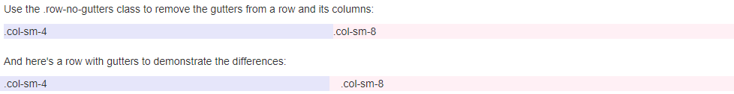

div class="row">  
  <div class="col-sm-8">  
    .col-sm-8  
    <div class="row">  
      <div class="col-sm-6">.col-sm-6</div>  
      <div class="col-sm-6">.col-sm-6</div>  
    </div>  
  </div>  
  <div class="col-sm-4">.col-sm-4</div>  
</div>



<div class="row">  
  <div class="col-xs-9 col-md-7">.col-xs-9 .col-md-7</div>  
  <div class="col-xs-3 col-md-5">.col-xs-3 .col-md-5</div>  
</div>  
  
<div class="row">  
  <div class="col-xs-6 col-md-10">.col-xs-6 .col-md-10</div>  
  <div class="col-xs-6 col-md-2">.col-xs-6 .col-md-2</div>  
</div>  
  
<div class="row">  
  <div class="col-xs-6">.col-xs-6</div>  
  <div class="col-xs-6">.col-xs-6</div>  
</div>



<div class="row">  
  <div class="col-xs-6 col-sm-3">  
    Column 1  
    <br>  
    Resize the browser window to see the effect.  
  </div>  
  <div class="col-xs-6 col-sm-3">Column 2</div>  
  <!-- Add clearfix for only the required viewport -->  
  <div class="clearfix visible-xs"></div>  
  <div class="col-xs-6 col-sm-3">Column 3</div>  
  <div class="col-xs-6 col-sm-3">Column 4</div>  
</div>

